**SPL-1 Project Report, [2022]**

**Abstract Syntax Tree**

**SE 305: Software Project Lab 1**

Submitted by

**Mosamma Sultana Trina**

**BSSE Roll No. : 1313**

**BSSE Session: 2020-21**

Supervised by

**Dr. Sumon Ahmed**

**Designation: Associate Professor**

**Institute of Information Technology**



**Institute of Information Technology**

**University of Dhaka**

[21-05-2023]

Table of Contents

1. Introduction 3

1.1. Background Study 3

1.2. Challenges…………………………………………………………………………………………………………………………...6

2. Project Overview……………………………….................................................................................6

3. User Manual………………………………………………………………………………………………………………………………….12

4. Conclusion……………………………………………………………………………………………………………………………………15

References………………………………………………………………………………………………………………………………………..16

# Introduction

# My project is to build Abstract Syntax Tree for C source code. An abstract syntax tree (AST) is a data structure commonly used in computer science and programming language theory to represent the structure of a program. It is a hierarchical tree-like representation that captures the syntax and organization of the program's code, but abstracts away details that are not relevant to its structure, such as semicolon or specific formatting. The AST represents the syntactic structure of the program by breaking it down into individual nodes, where each node corresponds to a specific construct in the programming language. For example, in a language like C, an AST node might represent a variable declaration, assignment, or a loop construct. ASTs are useful for several reasons. Such as **Compilation and Interpretation, Static Analysis, Code Transformation and Refactoring.**

## Background Study

To lay a solid foundation for the project, an extensive background study was conducted to understand the concepts and techniques related to lexical analysis, parsing, and abstract syntax trees.

**Lexical Analysis:**

The first phase of building the abstract syntax tree is the lexical analysis. The lexical analyzer breaks these syntaxes into a series of tokens, by removing any whitespace or comments in the source code. A token is an object describing a lexeme. Along with the value of the lexeme (the actual string of characters of the lexeme), it contains information such as token ID, its type (is it a keyword? an identifier? an operator? …)

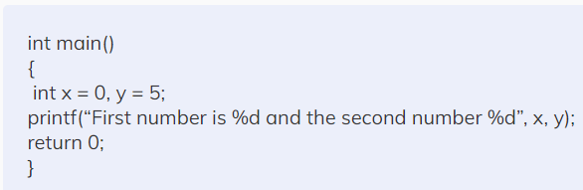

In the above example of lexical analysis, we can easily recognize that there are 27 tokens in the above code. Tokens in the code are ‘int’ ‘main’ ‘(‘  ‘)’ ‘{’ ‘int’ ‘x’ ‘=’ ‘0’ ‘,’ ‘y’ ‘=’ ‘5’ ‘;’ ‘printf’ ‘(‘  ‘“First number is %d and the second number %d ”’ ‘,’ ‘x’ ‘,’ ‘y’  ‘)’ ‘;’ ‘return’ ‘0’ ‘;’ ‘}’.

**Parsing or Syntax Analysis:**

## In syntax analysis, the compiler checks the syntactic structure of the input string, whether the given string follows the grammar or not. It uses a data structure called a Parse Tree or Syntax Tree to make comparisons. The parse tree is formed by matching the input string with the pre-defined grammar. If the parsing is successful, the given string can be formed by the grammar, else an error is reported.

The parsing techniques can be divided into two types:

**Top-down parsing:** The parse tree is constructed from the root to the leaves in top-down parsing. Some most common [top-down parsers](https://www.codingninjas.com/codestudio/library/top-down-parsing) are [Recursive Descent Parser](https://www.codingninjas.com/codestudio/library/recursive-descent-parser) and LL parser.

**Bottom-up parsing:**The parse tree is constructed from the leaves to the tree’s root in bottom-up parsing. Some examples of [bottom-up parsers](https://www.codingninjas.com/codestudio/library/bottom-up-parsing) are the LR parser, SLR parser, CLR parser, etc.

Parse Tree:

Parse tree is the graphical representation of symbol. The symbol can be terminal or non-terminal. In parsing, the string is derived using the start symbol. The root of the parse tree is that start symbol. It is the graphical representation of symbol that can be terminals or non-terminals. It is a hierarchical structure which represents the derivation of the grammar to yield input strings.

* Root node of parse tree has the start symbol of the given grammar from where the derivation proceeds.
* Leaves of parse tree represent terminals.
* Each interior node represents productions of grammar.

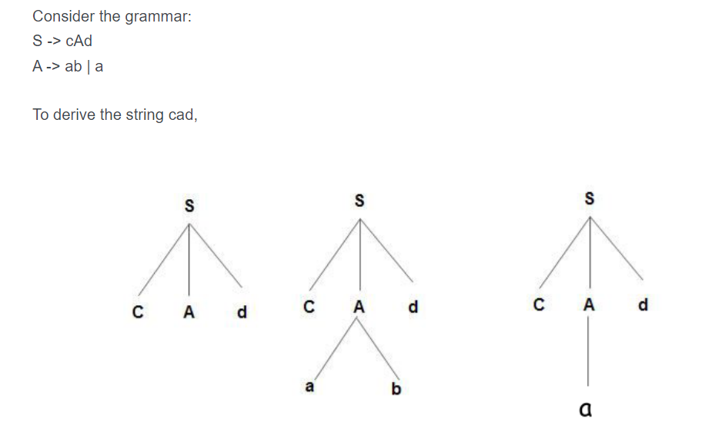

**Abstract Syntax Tree:**

Some compilers use an abstract syntax tree (AST) to represent the program being compiled. The AST has the essential structure of the parse tree but eliminates some of the unnecessary nodes. Some parse tree nodes may not be required in the AST representation, such as punctuation or parentheses. Exclude these nodes from the AST during the construction process.

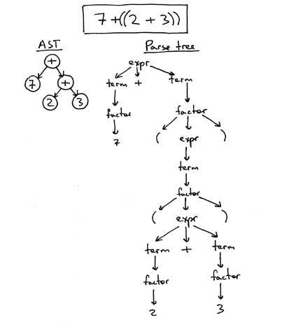

**Print Tree:**

To print the parse tree and abstract syntax tree, I use the Depth-First Search (DFS) algorithm. Additionally, I represent the tree using the general tree representation, known as the left child right sibling representation.

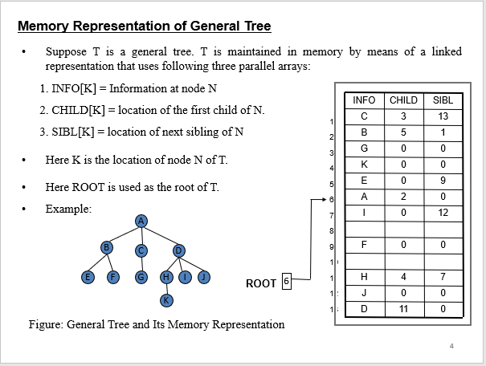

## Challenges:

New Challenges are always faced while implementing a software solution. While implementing the Abstract Syntax Tree, a lot of challenges were faced namely:

* Parsing Complexity: Understanding the concepts of parsing and dealing with source code proved to be quite challenging, especially for someone new to this area. Parsing code character by character was a time-consuming task that required careful handling of various cases and situations.
* Learning Context-Free Grammar: Mastering the intricacies of Context-Free Grammar (CFG), which defines the syntax rules of the programming language, required a significant time investment. It involved understanding components like terminals, non-terminals, production rules, and their relationships.
* Implementing Production Rules: Implementing the detailed production rules was the most difficult aspect of building the Parse Tree. It demanded a deep understanding of the code's structure and semantics to construct Parse Tree and AST.
* Handling Nested "if" Statements: Dealing with nested "if" statements adds complexity to the Parse Tree construction process. Managing the indentation levels, tracking the conditionals, and accurately representing the hierarchical structure of nested "if" statements requires careful consideration and implementation. Ensuring the proper nesting and capturing the correct semantics of the code within the parse tree was challenging, especially when there are multiple levels of nested conditionals.
* Limited Resources: Finding comprehensive and reliable resources online was a challenge. This scarcity hindered progress and required resourcefulness to explore alternative avenues for acquiring the necessary knowledge and guidance.
* Parse Tree to Abstract Syntax Tree: Converting parsed code into a suitable AST representation was a confusing task. Designing a logical structure that accurately captured the code's semantics and relationships was a little bit challenging.

## Project Overview

The project has mainly Three Steps:

* + - 1. Lexical Analysis
      2. Construct Parse Tree
      3. Build Abstract Syntax Tree

**Lexical Analysis:**

Lexing.cpp file uses the C source code and breaks it into tokens by removing the comments and extra white spaces used in the code. It also checks the invalid tokes after creating them. If there are any invalid tokens, the lexical analyzer stops analyzing the code and gives an error. Mainly, the Lexical analyzer checks the legal tokens and then forwards the code to the other phases. Some of the steps of tokenization is given below:

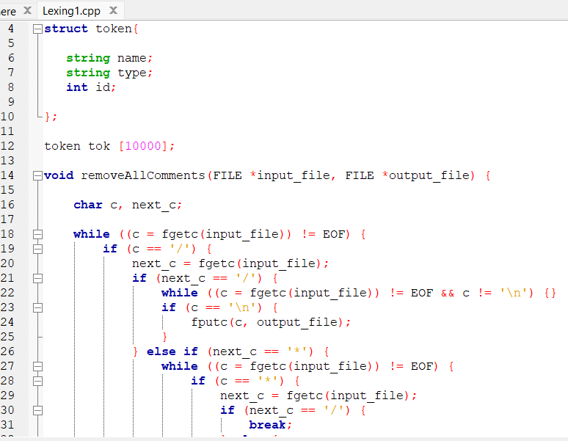

Each token contains its unique token ID.

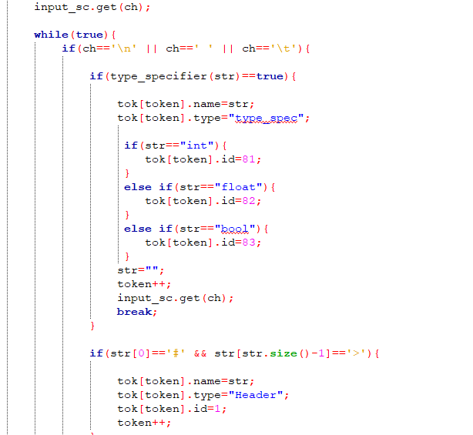

Here, we can see type specifiers and header files are being lexed from the source code.

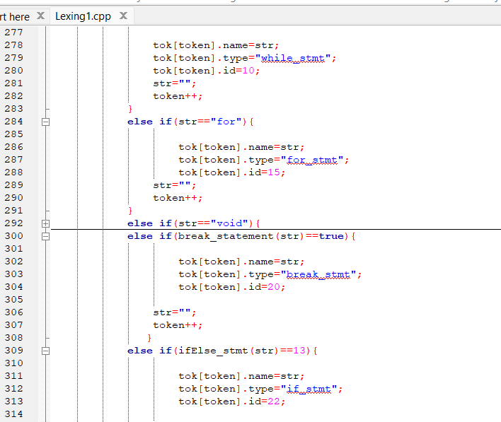

Here, we have detected break, if, while, for and converted them into tokens for further use.

**Construct Parse Tree:**

A parse tree will be formed with the tokens. Any irregularities with the Context Free Grammar will be determined from here. The prototypes of functions used in the Analyzer will be shown below whose activities can be guessed from their name:

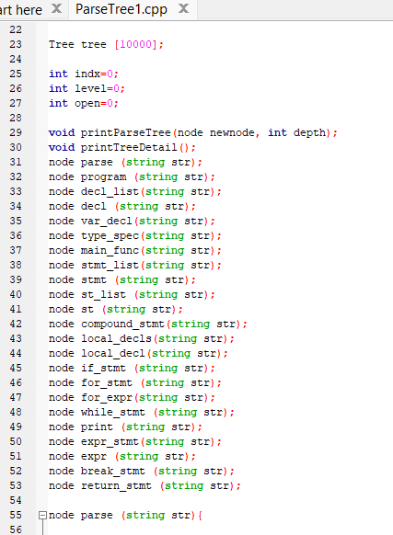

These are the functions used for constructing Parse Tree. Now the Context Free Grammar whose help has been taken in building Parse Tree:

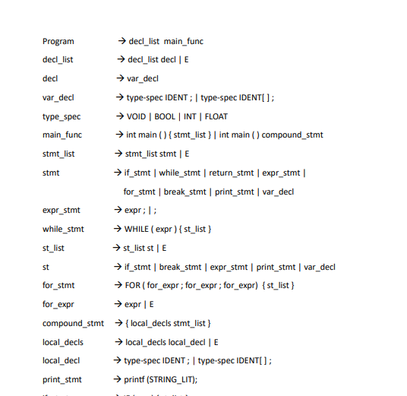

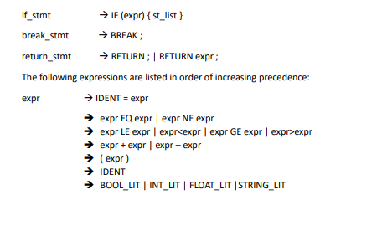

**Build Abstract Syntax Tree:**

To build an abstract syntax tree from a parse tree, we need to remove unnecessary nodes such as brackets, semicolons, and any node whose child is "E" (epsilon).

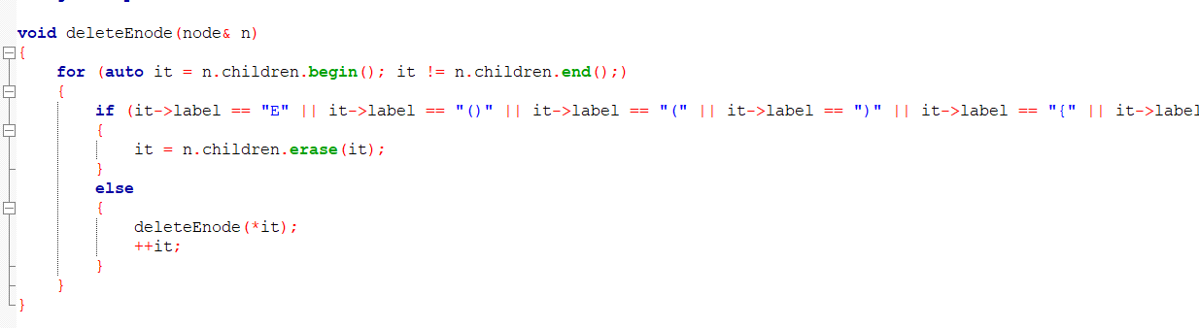

Traversing and printing a tree by calling a recursive function, it is commonly referred to as performing a depth-first search (DFS) traversal. DFS starts at the root of the tree and explores as far as possible along each branch before backtracking.

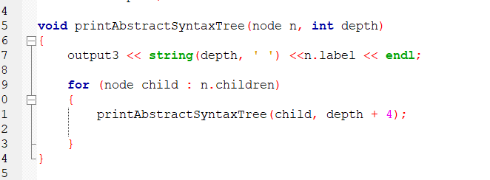

printAbstractSyntaxTree function takes two parameters: n represents the current node being visited, and depth represents the current depth level in the tree. The function prints the label of the current node with an indentation based on the depth level.

# User Manual

Before running the project, you need to create an input file that contains the C source code.

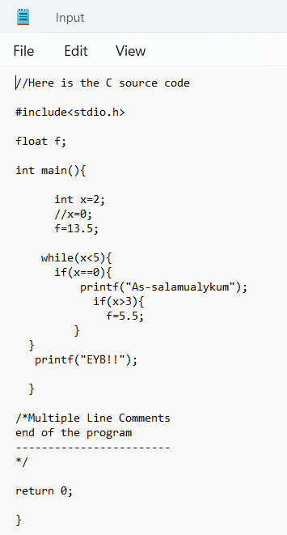

The project consists of four C files: Lexing1.cpp, ParseTree1.cpp, AST1.cpp, and drive.cpp. To run the project, start by executing the drive.cpp file. This will trigger the execution of Lexing1.cpp, which will generate the following outputs:

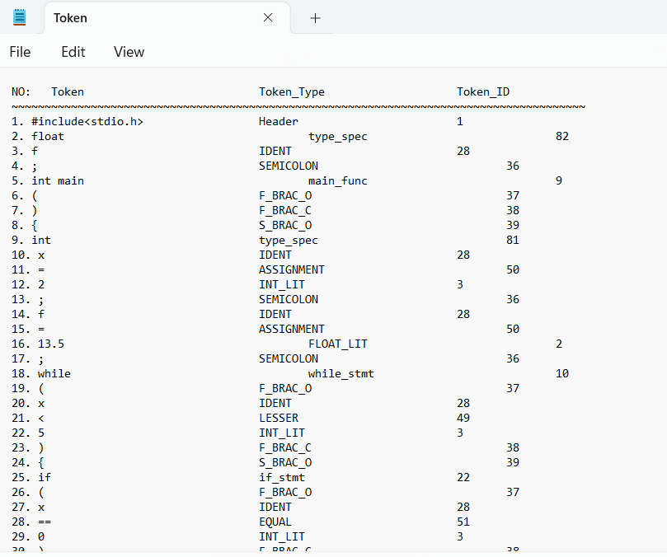

Afterward, execute ParseTree1.cpp, which will produce a parse tree containing detailed information about the source code.

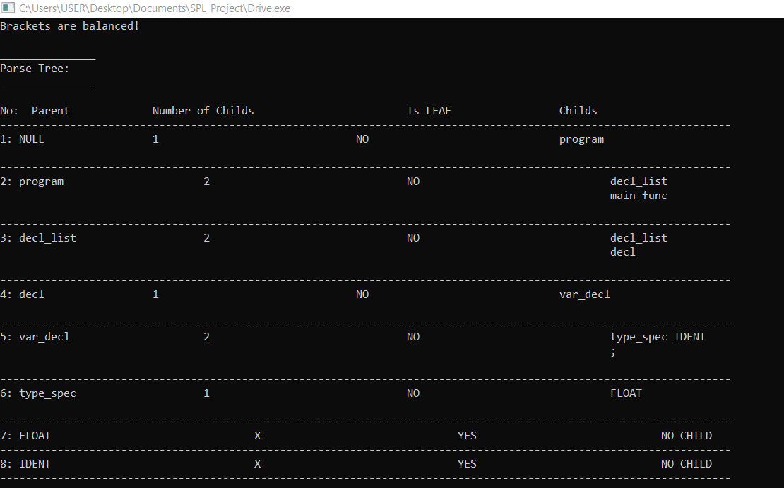

Finally, run AST1.cpp to construct an abstract syntax tree (AST) from the parse tree, eliminating unnecessary nodes. The program will then print the AST using depth-first traversal.

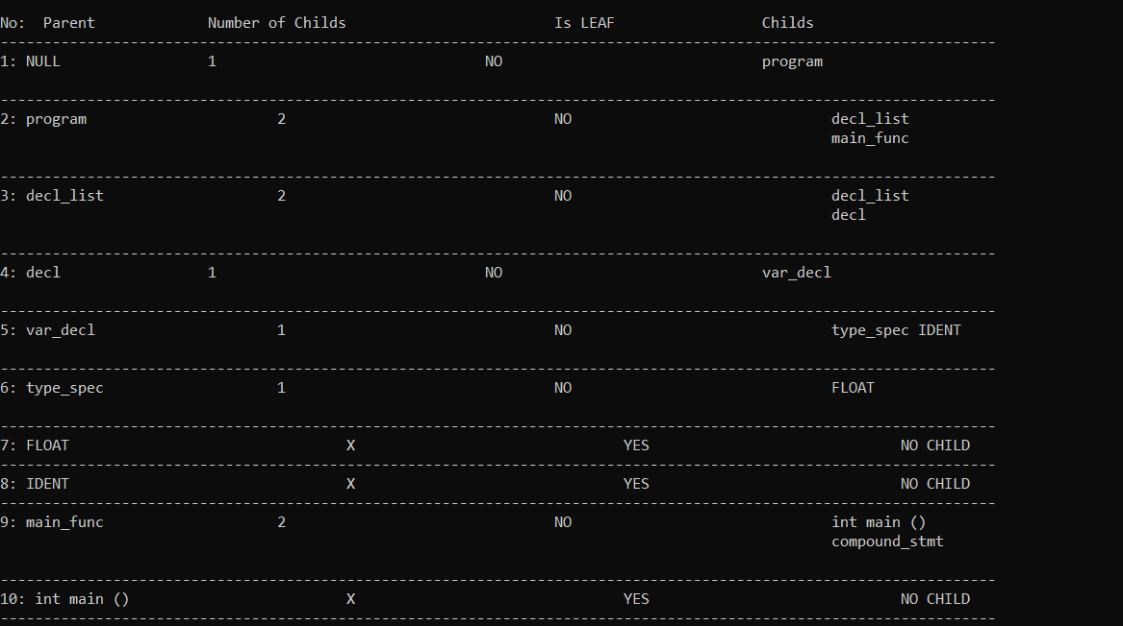

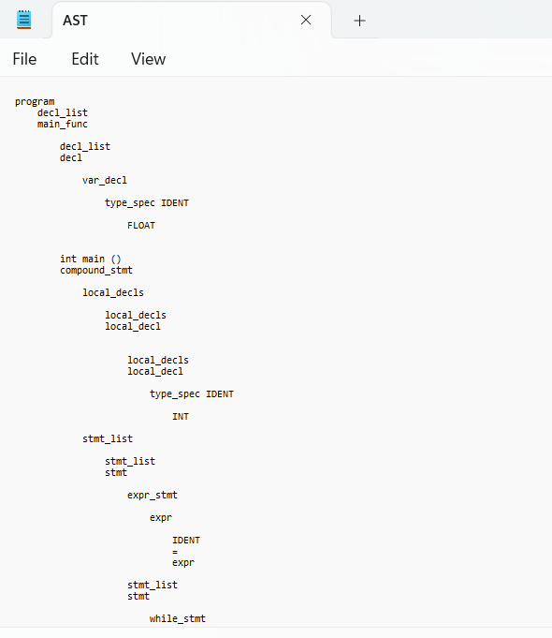

Therefore, the abstract syntax tree has been constructed in the above

stated manner.

# Conclusion

# In conclusion, this project has been instrumental in enhancing my understanding of compiler operations and has provided me with valuable insights into various aspects of code analysis and parsing. Through this project, I have gained a deeper understanding of how compilers work and the importance of managing code effectively. Handling large lines of code has become more manageable. I have built the Abstract Syntax Tree (AST) for a specific domain (if statements, nested if statements, while loops, and for loops). The AST accurately represents the syntactic structure of the code within this domain. However, I have plans to extend the functionality of the AST in the future so that it can handle and build ASTs from any valid C source code, regardless of the specific domain or constructs used. This expansion will involve enhancing the parser and AST construction algorithms to handle a broader range of C language features and syntax

# 

# References

1. https://ruslanspivak.com/lsbasi-part7/, ruslanspivak.com, last accessed on 17.05.2023
2. Research paper on Compiler Design, Jatin Chhabra, Hiteshi Chopra, Abhimanyu Vats, INTERNATONAL JOURNAL OF INNOVATIVE RESEARCH IN TECHNOLOGY, 2014, 151
3. https://www.twilio.com/blog/abstract-syntax-trees, twilio.com, last accessed on 22.04.2023
4. https://www.cs.wcupa.edu/rkline/fcs/parse-trees.html, .cs.wcupa.edu last accessed on 11.04. 2023